Replace Steps 37 etc. with the following:

Step 37 Source: Notes TWO Screen:
Karl and Carmen had Medicare all year.
Kara had no health insurance from January through March while she was unemployed. Your local ACA expert says that Kara did not qualify for any exemption during this period. She had health insurance through her employer from April to December.
Kendra and Dave had insurance for January through June from a Marketplace policy. They elected to not take any advance of the premium tax credit relating to this policy. During July and August they had no health insurance. From September to December they were both covered through Kara’s employer.
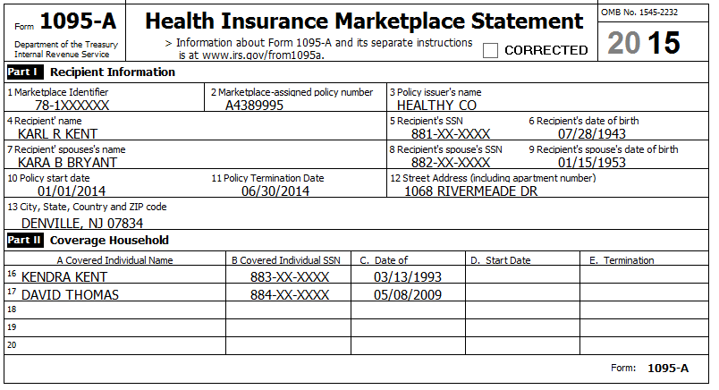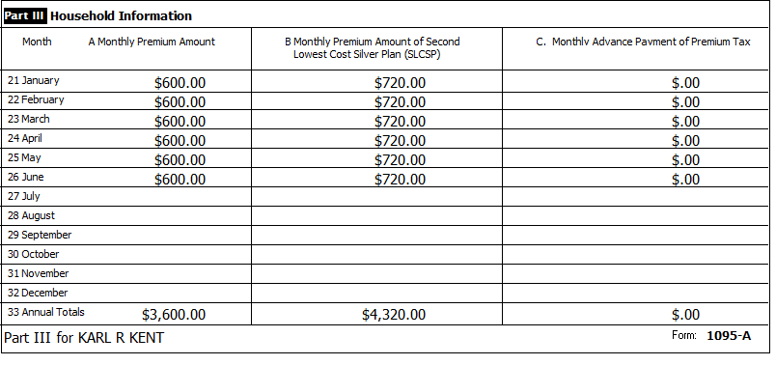
Reference: 4012 ACA Tab
Reference: ACA TaxWise Procedures (TY2014 version)
Step 37a Source: Notes TWO Screen: 1040 ACA Wkt
[see Notes above]
Refund Monitor
AGI | Refund | NJ 39 | NJ 56/66 | Notes
78,650 | 4,974 | 18,996 | 2,207 | Hint: Follow Step 3 of ACA TaxWise Procedures
Step 37b Source: Notes TWO Screen: 8965
[see Notes above]
Refund Monitor
AGI | Refund | NJ 39 | NJ 56/66 | Notes
78,650 | 4,974 | 18,996 | 2,207 | Hint: Follow Step 4 of ACA TaxWise Procedures
Step 37c Source: Notes TWO Screen: 1040 ACA Wkt
[see Notes above]
Refund Monitor
AGI | Refund | NJ 39 | NJ 56/66 | Notes
78,650 | 4,830 | 18,996 | 2,207 | Hint: Follow Step 5 of ACA TaxWise Procedures  Check: Line 14 = 144
Step 37d Source: Notes TWO Screen: 8962
[see Notes above]
Refund Monitor
AGI | Refund | NJ 39 | NJ 56/66 | Notes
78,650 | 5,346 | 18,996 | 2,207 | Hint: Follow Step 6 of ACA TaxWise Procedures  Check: Line 26 = 516
Step 37e Source: Notes TWO Screen: A Detail
[see Notes above]
Refund Monitor
AGI | Refund | NJ 39 | NJ 56/66 | Notes
78,650 | 5,804 | 15,912 | 2,250 | Hint: Follow Step 6 of ACA TaxWise Procedures  Check: Medical Expenses Total = 15,107
Step 38 Source: Notes TWO Screen: Diagnostics
Run Diagnostics (and Create e-File) – Resolve any issues (and don’t forget to celebrate finishing the Kent problem!!)
For a client return, the next step would be Quality Review…

